Hosted Services Password Reset and Login

Resetting your Password
To reset your password, follow the below steps:
- Go to the hosted website: https://hosting.epmorris.co.uk/RDWeb/Pages/en-US/login.aspx
- Enter your username and password sent by a member of the Velociti Support Team e.g.
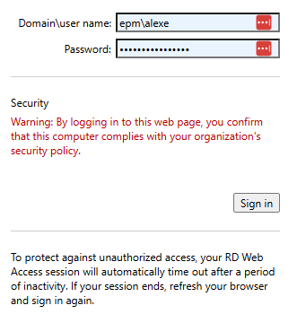
- Domain\user name: the Domain is epm\ followed by your user name
- Password: this is your temporary password sent by Velociti Support

- Click Sign in and the below message will appear
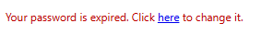
- Click here to change your password
- The below screen will appear:

- 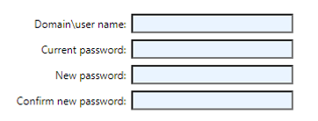
- Domain\user name: the Domain is epm\ followed by your user name
- Current Password: this is the temporary password sent by Velociti Support
- New password: this is your new password which must meet the following requirements:
- Must be 12 or more characters in length
- Must contain an uppercase character
- Must contain a number
- Must contain a special character
- Cannot repeat a password across a history of the last six months
- Cannot contain identifiable names

- Click Submit when finished
- Your new password will have been set, click OK to reload the page and login with your new password

Logging In
To login to the Velociti 6D hosted application, follow the below steps:

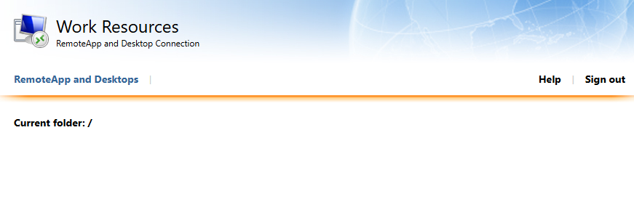
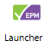
- Once logged in, you will see the Launcher icon as shown below
- Click the Launcher to download the RDP launcher:
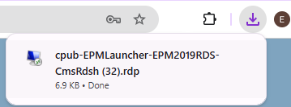
- Open the download and re-enter your login credentials including the epm\ domain
- After clicking OK¸ this will open the Application Launcher screen:

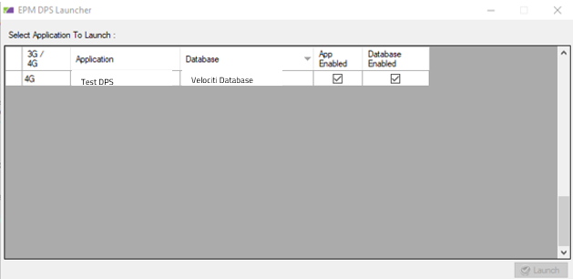
- Select the application and click Launch to open the system

